Ongoing issues with BOIPA

Background

Site Details:
www.tcsp.ie
MID: 100121

Developer Details :
Contact: Morgan McKnight
Mobile: +353 (0)85 1742218
Email: morgan.mcknight@gmail.com

Manager Details
Brian Sweeney (Pool Manager)
Mobile: +353 (0)86 8200084
Email: swimming@tcsp.ie

Live Testing

Our set-up details.

We are using the following plugin:

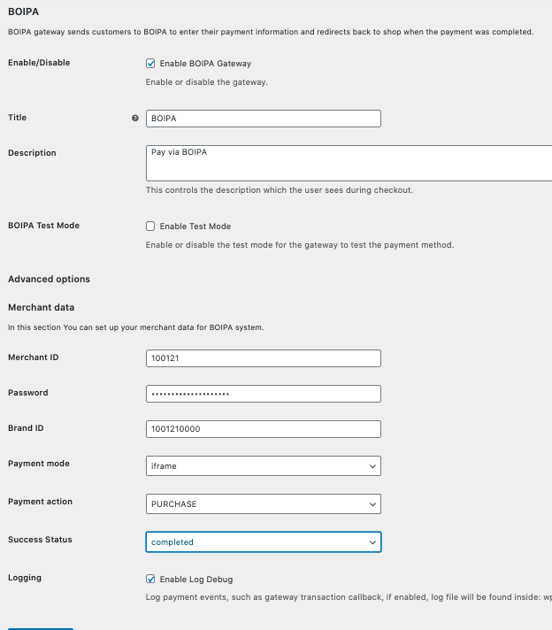

We use the following credentials:
MID: 100121
Brand ID: 1001210000
API Password: u0AYACBNI2643G87wk4o

What the problem is?

- On placing an order using the BOIPA gateway, we get s confirmation notice (indicating payment has been accepted).
- The money is taken from the customer’s account and the order is put into status ‘completed’
- An email is sent to customer confirming completion.
- An email is sent to the customer saying it is being processed.
- The customer is redirected to another page which gives this message:
- 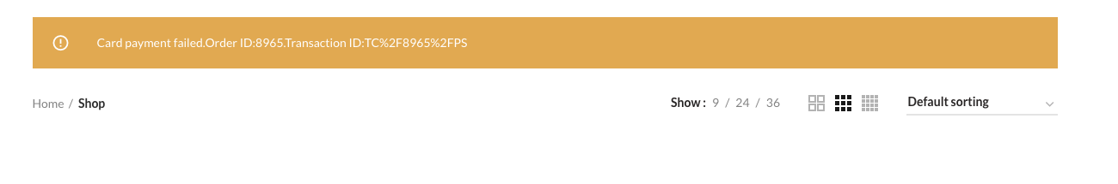
- The order status is changed from ‘completed’ to ‘failed’.
- The customer is redirected to the home page.

We then get three emails: The first at the bottom says we have paid, the second says we are processing the third says we have paid (again).

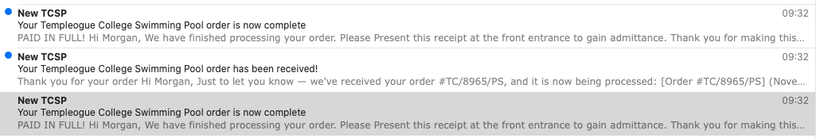

Using the Intelligent Payments Gateway
When we use the Intelligent payments Gateway/plugin.

It works as expected we get a correct confirmation of payment and the customer is redirected to our own Thank you Page.

Using Stripe Sandbox

All works fine.

Using BOIPA’s test payments gateway:

MID: 100121
Brand ID: 1001210000
API Password: qWGEJQQAkhROSTGpwS5O

Please ensure test mode is ticked on the back end.
Card Number: 4111 1111 1111 1111
CVV: 111
Expiry: 12/23
Name: Any Name

The Issue:
It does not work on the BOIPA gateway nor the Intelligent Payments gateway.

